
NAME: M NASEEM
ROLL NO: 055
SECTION: BSSE-4A
SUBJECT: AI(lab)
SUBMITTED TO: RASIKH ALI

Manual Trace of BFS and DFS
1. Introduction
In this task, I used two search methods, Breadth-First Search (BFS) and Depth-First Search (DFS), to find the goal node G, starting from node A.
The graph is differently searched by both methods, and as well, meanwhile, DFS goes deeper into one branch before moving to another, on the whole. BFS checks nodes level by level.
2. Original A, G Graph
The following is, of course, the original graph given in Section 3.2.
Graph representation
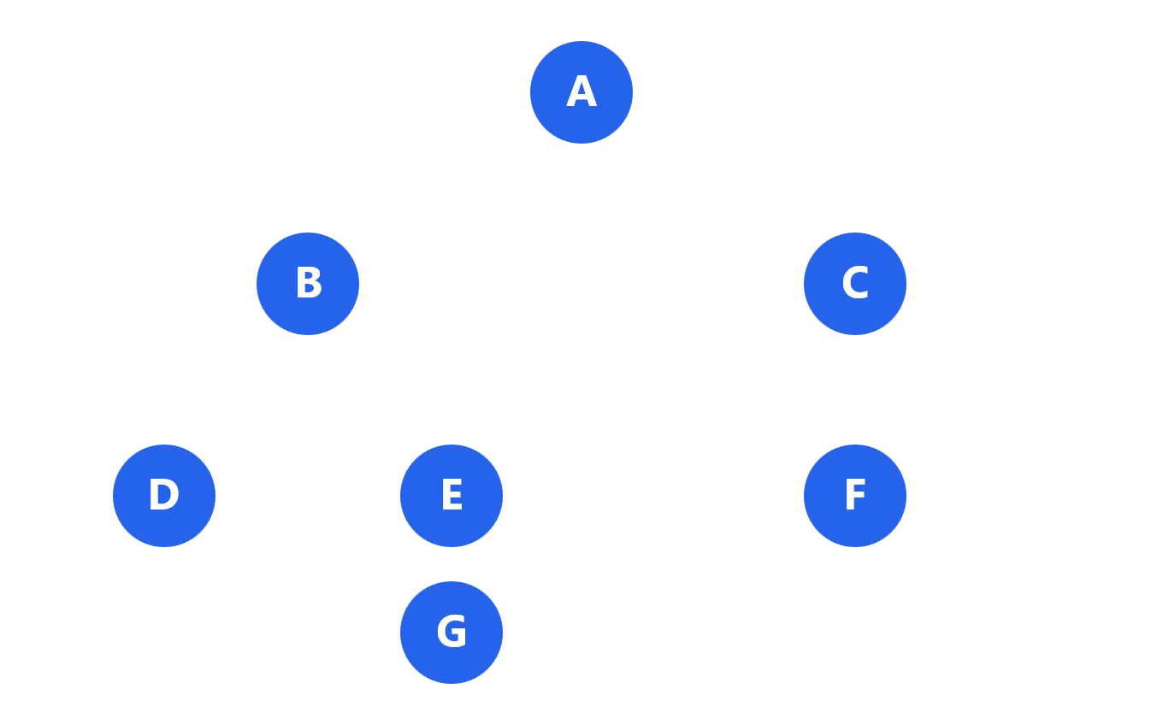

Start node: A | Goal node: G
Successor order from the given code:
- A → B, C
- B → D, E
- C → F
- D → No child
- E → G
- F → No child
- G → No child

3. Breadth-First Search (BFS)
BFS visits nodes level by level, and is using a Queue (FIFO), which means the first node added is the first one handled, broadly speaking.
BFS manual trace
Step | Queue (front first) | Processed node | Path
1 | [A] | A | A
2 | [B, C] | B | A → B
3 | [C, D, E] | C | A → C
4 | [D, E, F] | D | A → B → D
5 | [E, F] | E | A → B → E
6 | [F, G] | F | A → C → F
7 | [G] | G (Goal) | A → B → E → G

The search stops when G is ran.

BFS final path:
Goal found
A → B → E → G
BFS visit order:
A → B → C → D → E → F → G
4. Depth-First Search (DFS)
DFS explores one branch as deeply as possible before going back to another branch. And it's employing a Stack (LIFO), which means the last node added is the first one performed, in actual application.
The given code employs reversed() to follow the original successor order.

DFS manual trace
The right side of the stack is, in practice, the next node to be handled, on the whole.
Step | Stack (next node on right) | Processed node | Path
1 | [A] | A | A
2 | [C, B] | B | A → B
3 | [C, E, D] | D | A → B → D
4 | [C, E] | E | A → B → E
5 | [C, G] | G (Goal) | A → B → E → G

Okay then, Node C is still waiting in the stack, in real-world scenarios, so bluntly, when G is mainly ran, the search is stopping, to a significant degree.
DFS final path:
Goal found
A → B → E → G
DFS visit order:
A → B → D → E → G
5. Comparison of BFS and DFS
Detail | BFS | DFS
Data structure | Queue | Stack
Search method | Level by level | Deep into one branch
Visit order | A, B, C, D, E, F, G | A, B, D, E, G
Final path | A, B, E, G | A, B, E, G
Goal found | Yes | Yes

6. Verification with Python Code
The manual findings were validated employing the supplied BFS and DFS Python code.
Popleft is being employed by the BFS code() to remove the first node from the queue, in many respects.
Pop( is being employed by the DFS code) to remove the last node from the stack. It also is using reversed() to follow the given successor order, to a noticeable degree, to a significant degree.
Python output:
python
['A', 'B', 'E', 'G']
['A', 'B', 'E', 'G']

The manually found paths are, by design, currently being matched by both findings.
7. Conclusion
In this task, the goal node G was successfully found by both BFS and DFS, starting from A, in real-world scenarios.
BFS visited more nodes because it checked out the graph level by level, so DFS hit the goal by following one branch first, in real-world scenarios.
Both methods found the same final path:
A → B → E → G
The manual traces match the supplied Python code, so the findings are correct.

